Good morning

I was in the sandbox and trying to differentiate between a finding and an Observation (opportunity for improvement) when doing an audit.

Right now it appears the an observation is the same as a finding except in the description. See below screen shot

Is there a way to add something that they can be filtered or look different when you view Action Register? Or maybe I am looking wrong?

Also if I was to add a finding or an observation to an audit, it would be nice to choose if its an observation or a finding of non-compliance.

Your help would be greatly appreciated.

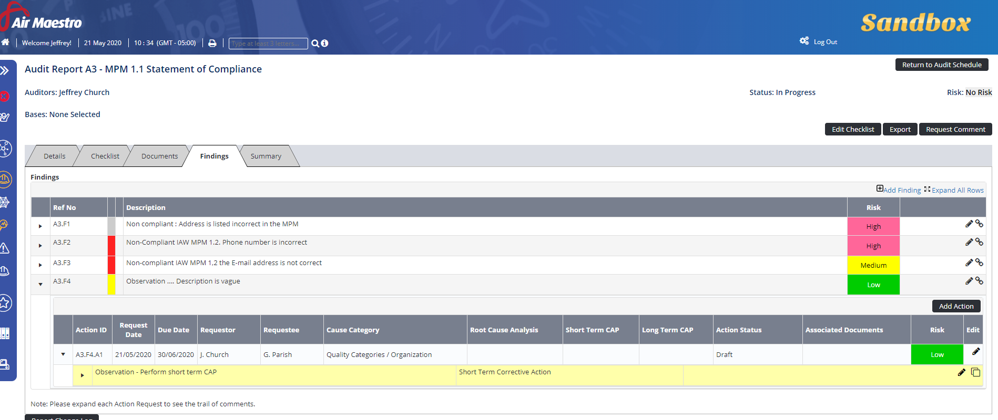

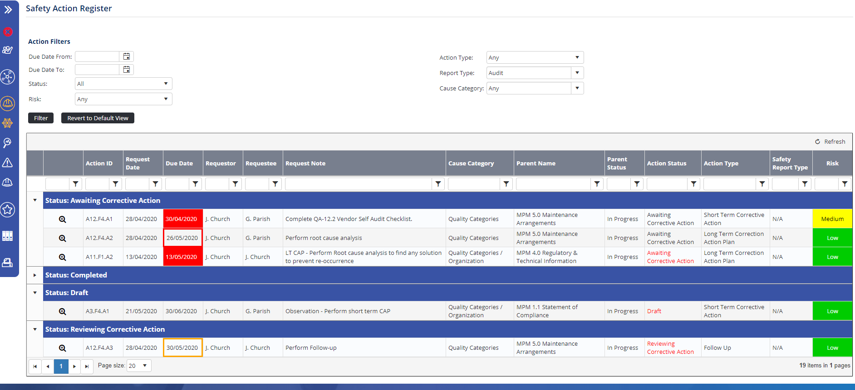

From: Liam Magee <helpdesk@avinet.atlassian.net>
Sent: May 21, 2020 10:41 PM
To: Church, Jeffrey <Jeffrey.Church@babcockinternational.com>
Subject: CAUTION: External email - AMHD-1990 Observations (UNCLASSIFIED)

—-—-—-—
Hi Jeffery,
Unfortunately there is no way to change the colour of or filter out an observation in the action register as it has no filters that pull from the contents of the Description.
The only thing we could offer is to pull a global report and attempt to filter from the description from there.
Otherwise if you would like to see this as well as an observation option when lodging a finding, it would be best to lodge this as an Idea in the Ideas Portal.
If you have any questions please let us know.
Kind regards,
Liam Magee
Customer Support

