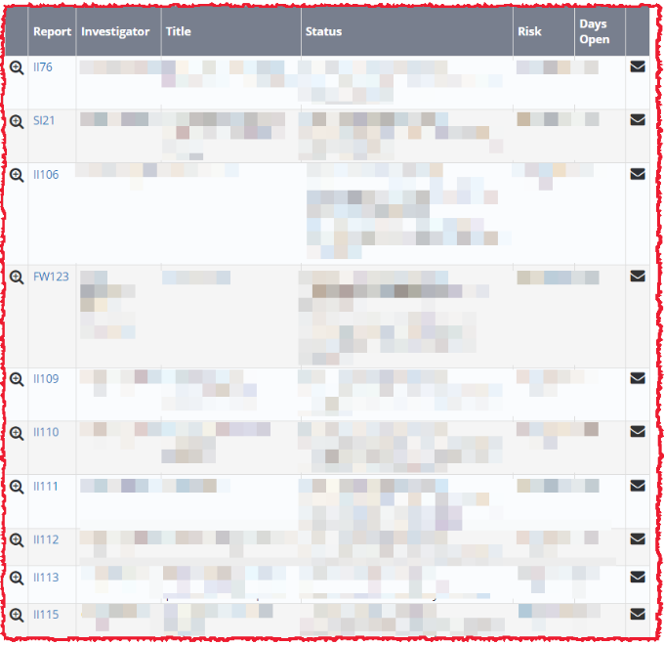
Figure 1
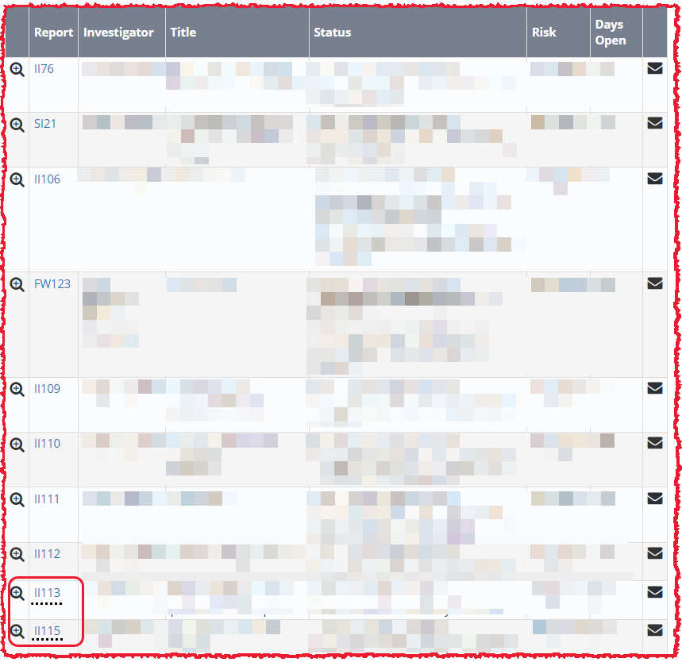
Figure 2
On home page summary page and lists active safety reports – Figure 1
Having underlines appear if there are linked reports (Figure 2) could a useful addition.

As in access levels if cursor above dotted lines causes a pop up displaying the linked report number(s) likely useful for analysis when trying to quickly see if there are similarities between the reports.

